➢ Mangalparthy Mahesh 

➢ S Muhaideen abdul kader

➢ D.Vikram kanth

➢ Mohamed Rehnaz Ashraf

Prediction Of Oil Price Present by team 4

Team members

➢ Sanket raut

➢ R.Vishnu Vardhan Reddy

Date : 27/06/2023

model aims to analyze the patterns in oil prices to assist customers

Objective :

Oil prices are often influenced by factors outside of immediate information, which makes it difficult to predict them accurately. These prices can have a significant impact on the economy. Our

and businesses in making informed decisions.

Project Architecture / Project Flow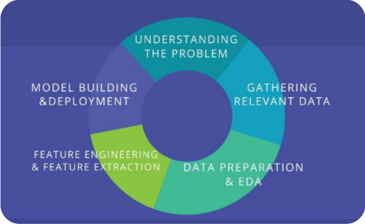

Dataset 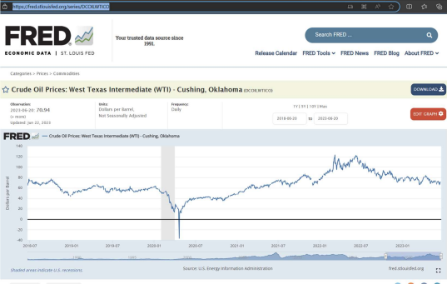

Crude Oil Prices: West Texas Intermediate ~~(WTI) - Cushing, Oklahoma (DCOILWTICO) |~~

Source: U.S. Energy Information Administration

Link

FRED | St. Louis Fed (stlouisfed.org)

Exploratory Data Analysis (EDA)

In this dataset 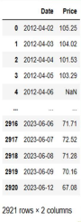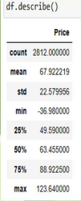

✓The dataset consists of 2 columns: "Date" and "Price". ✓The dataset contains 2,921 entries.

✓The "Date" column is of the datetime data type. ✓The "Price" column is of the float data type. ✓The "Price" column has 2,812 non-null values, indicating some missing data.

✓The average price in the dataset is approximately 67.92. ✓The standard deviation of the prices is around 22.58. ✓The minimum price recorded in the dataset is 36.98. ✓The 25th percentile of prices is 49.59, meaning 25% of the prices are below this value. 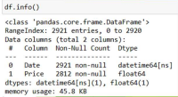

✓The median price is 63.45, indicating that 50% of the prices are below this value.

✓The 75th percentile of prices is 88.92, meaning 75% of the prices are below this value.

✓The maximum price recorded in the dataset is 123.64.

Feature Engineering 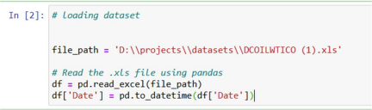

➢ Assigns the converted datetime values back to the

'Date' column in the DataFrame. 

➢ Conversion to datetime format allows for easier

manipulation and analysis of dates.

➢ The code prepares the dataset for further analysis and manipulation by ensuring the 'Date' column is treated

as a date/time data type.

1. The "Date" variable has no missing values. 

2. The "Price" variable has 109 missing values.

1. Both the "Date" and "Price" variables have 

2. The "Year" variable also has no missing

Handle Missing Data

✓ Before handling missing values:

✓ After handling missing values:

no missing values.

values.

Total number of values: 2921 and Number of null values in the "Price" variable: 109 Percentage of null values in the "Price" variable: (109 / 2921) * 100 = 3.73% approximately 3.73% of the values in the "Price" variable are null.

Library Pandas

• Pandas is used for data manipulation, indexing, filtering, updating, and preprocessing • It allows operations such as data alignment, column selection, visualization, and

prioritized splitting.

Matplotlib

• Matplotlib is used in Python for generating graphics and visualizations, including plots,

charts, and figures.

• It supports various types of plots, including bar graphs, line graphs, pie charts,

scatter plots, histograms, and more.

Seaborn

• Seaborn is used for data visualization, data exploration, and chart customization in data science. 

• It enables dynamic updating, exploratory development, partitioning usage, and the creation of various plots like box plots, violin plots, swarm plots, and others.

Scikit-learn (sklearn)

• Scikit-learn is a powerful machine learning library used for various tasks like classification, regression, clustering, and dimensionality reduction.

• It provides tools for model selection, preprocessing, evaluation, and scoring, along with a wide range of machine learning algorithms and utilities.

Visualization [ Trend ]

✓ Oil prices were relatively high, ranging between 100 to 120 units, in 2012. 

✓ Subsequently, there was a consistent downward trend in oil prices.

✓ In the first month of 2020, there was a sharp decline, with oil prices hitting a low point of around 30 units. 

✓ However, in 2023, there has been an upward trend, suggesting a recent increase in oil prices.

After analyzing the data, it has been determined 

Outlier’s

1.Outlier Percentage:

that only 0.04% of the data points are considered

outliers.

1.Definition of Outliers:

Outliers are data points that significantly deviate

from the rest of the dataset. They can be unusually

high or low values compared to the majority of the

data. 

1.Impact on Data:

2.Since the percentage of outliers is extremely low

(0.04%), their presence has a minimal effect on the

overall dataset.



Distribution of data



The dataset is not normally distributed, as indicated by the non-linear trend in the Q-Q plot, deviating from the expected line for a normal distribution.

Normal distribution



✓Use scikit-learn's QuantileTransformer to transform 'Price' column.

✓Reshape 'Price' column to match the input format.

✓Transformed data now follows a normal distribution.

✓Use transformed data for analysis or modeling, considering normal distribution assumptions. ✓Apply quantile transformation using fit_transform method.

Correlation

✓ Weak negative correlation (-0.215) between 'Price' and 'Year’. 

✓ 'Price' tends to decrease slightly as 'Year' increases.

✓ Correlation is not strong or significant.

✓ Correlation does not imply causation. 

✓ Visualization helps identify potential relationships and patterns.

➢EDA (Exploratory Data Analysis) was performed on the dataset.

➢ Missing or null values in the dataset were identified and replaced with appropriate values.

➢Outliers in the data were detected, but they were determined to have no significant impact on the dataset, so they were retained.

➢The data was transformed to achieve a normal distribution. 

➢With these steps completed, the dataset is now prepared and ready .

for further processing or analysis.

Thank you

